**Rendering Lists And Conditional Statements.**

Rendering data dynamically in react can be done as follows:-

We can use .map method to iterate through the array and render the lists.

How to render stateful lists.

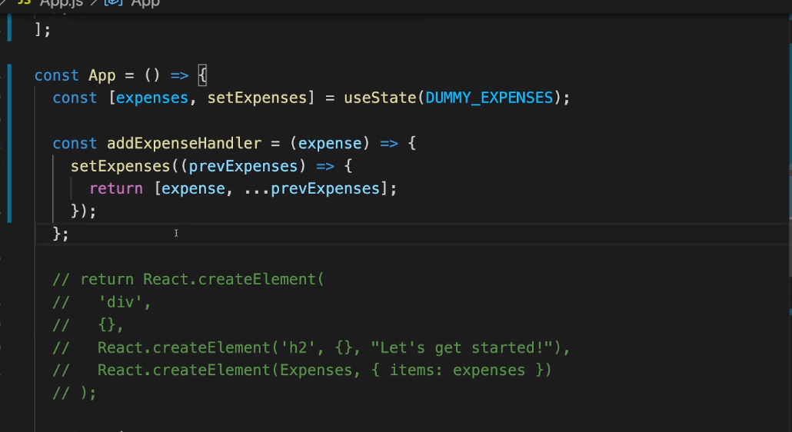

We need to add key prop to the rendered list of items. If unique id is not present , then we need to add an index to it. Following is the code snippet.

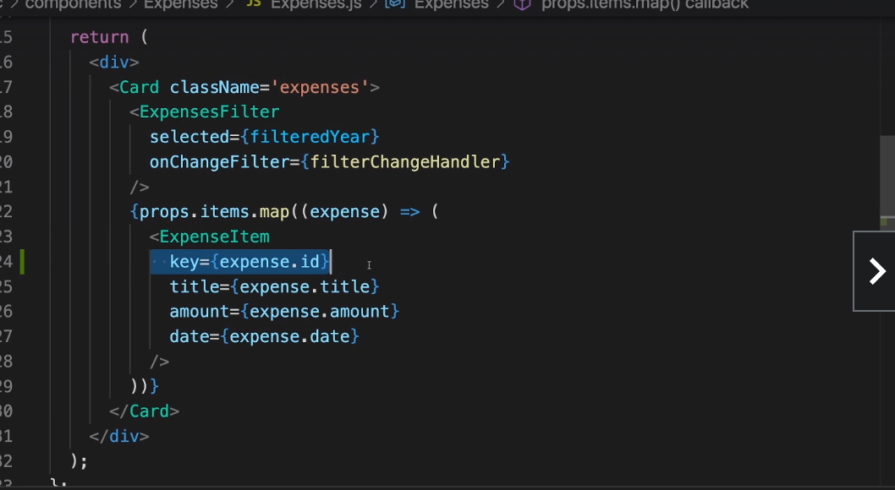

Conditional content rendering:-

Long statement like if or for loop are not supported in the curly braces.

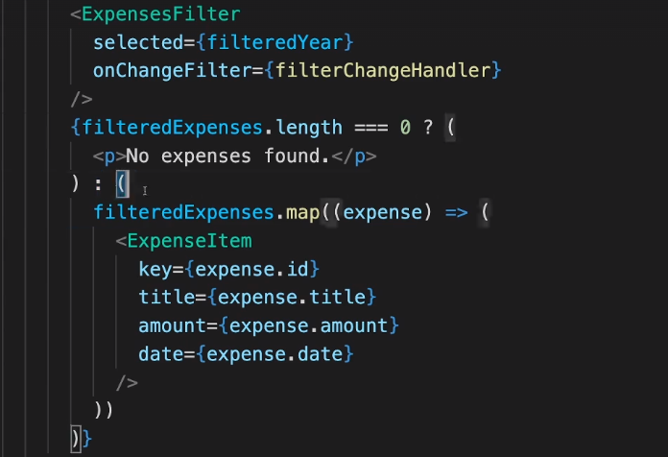

Alternative way could be using variables for JSX contents:-

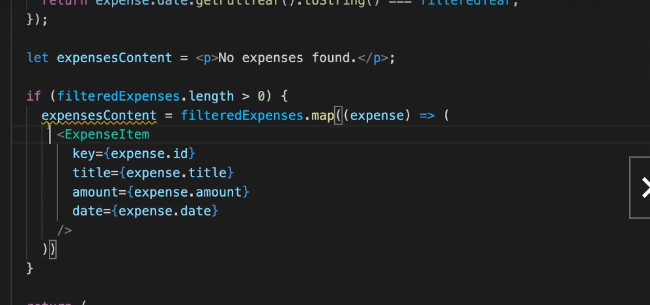

Adding dynamic css we can refer a following code snippet. In the below code snippet we are dynamically rendering the bar fill height using stype property.

